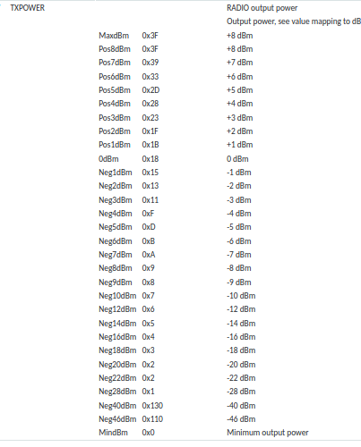

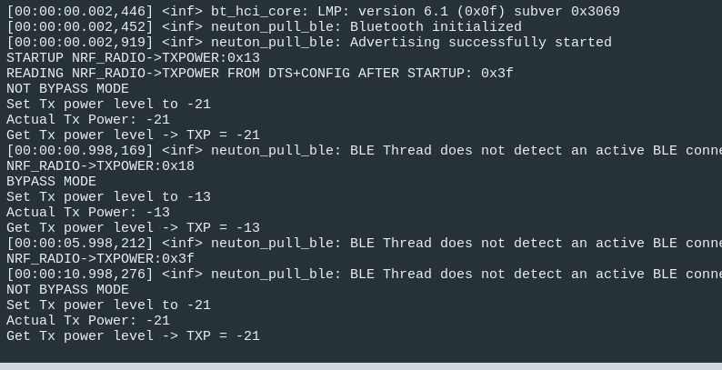

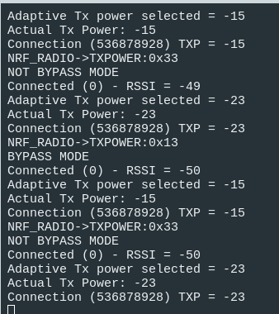
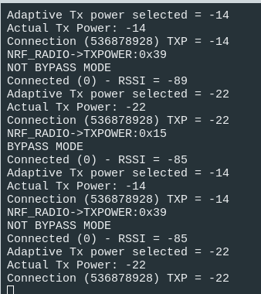
Good conn Bad conn
Changed tx-gain-db to be the bypass loss (-21dBm).
Antenna config defaults to 0, sothe “target” by all the math will be -21, so game the HCI TXPWR asks around that target to get valid results for TXPOWER.

. TXPOWER (SoC dBm) = Sum TXPWR (soc+fem)
Good conn → no bypass : 0x13 (-2dBm) = 19 dBm (ask for -23, 21-2=19 dBm)
w/ bypass : 0x33 (+6dBm) = 6 dBm (ask for -15=-21+6)
Bad conn → no bypass : 0x15 (-1dBm) = 20 dBm (ask for -22, 21-1=20 dBm)
w/ bypass : 0x39 (+7dBm) = 7 dBm (ask for -14=-21+7)

if NOT using inverse logic.. But move to big positive targets
i.e. fem gain is 21.
Then
bypass mode: try +21 set tx to +8, but get 0x5 (-14dBm)
[not correct!]
no bypass : set tx to +21, but get 0x15 (-1dBm) [correct!]

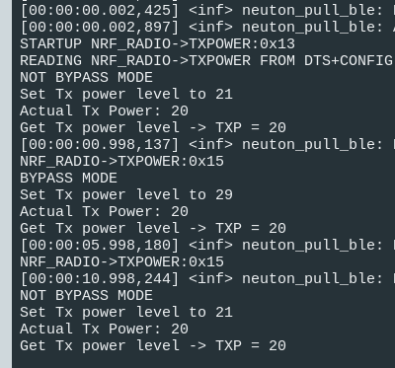
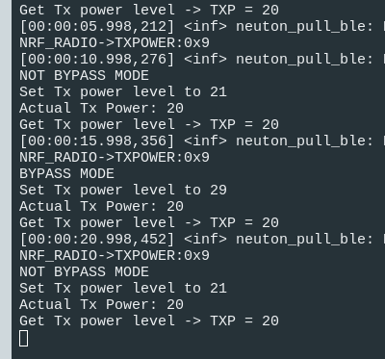
nope. Caps it to the fem gain in dts. Even if you try to bump the dts to +28, it just makes the soc gain MORE negative. (right)

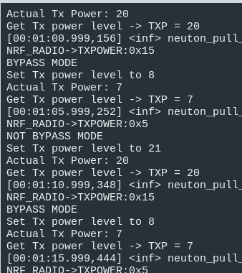

if NOT using inverse logic.. i.e. I ask for 20/7 and my FEM GAIN is +21 in dts.
Then
bypass mode: set tx to +8, but get 0x5 (-14dBm)
[not correct!]
no bypass : set tx to +21, but get 0x15 (-1dBm) [correct!]

